VPC-02 TASKS

Create one VPC, with 1 public subnet and 1 private subnet.

Go to aws console
Go to vpc service
Create vpc ‘my-vpc’

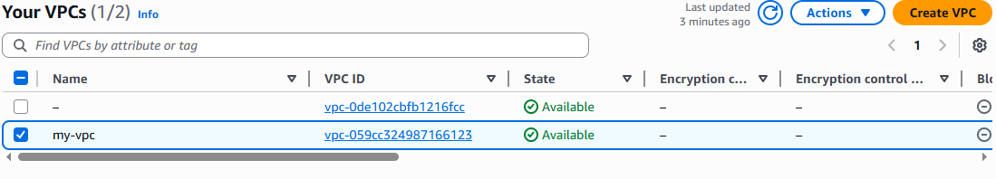
create 2 subnets public and private.
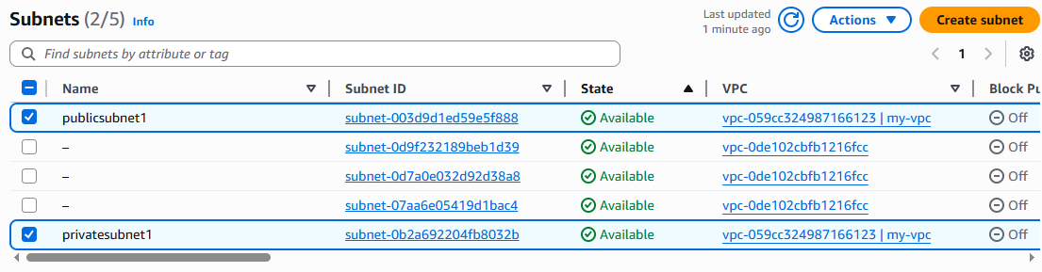
Create vpc and public subnet in another region.

Enable VPC peering for cross-region.

Go to aws console
create on vpc in one region(Mumbai)
create public subnet
edit route tables 0.0.0.0/0 internet gateway
launch ec2 and add vpc and subnet

create on vpc in one region(Hyd)
create public subnet
edit route tables 0.0.0.0/0 internet gateway
launch ec2 and add vpc and subnet
inbound rules to all traffic

To Peer to another vpc which is in another region

Go to vpc peering you want to request to another vpc
create peering connection
add vpc id of requester and accepter

Go to another region vpc peering and accept the peering request
Go to route tables edit and add route of CIDR of another region vpc and target to peering connections
come another region vpc route table and add the CIDR of acceptor region target to peering connections

connect to the instance of requester ec2 region and ping to private ip of acceptor instance
peering connection will be successful.
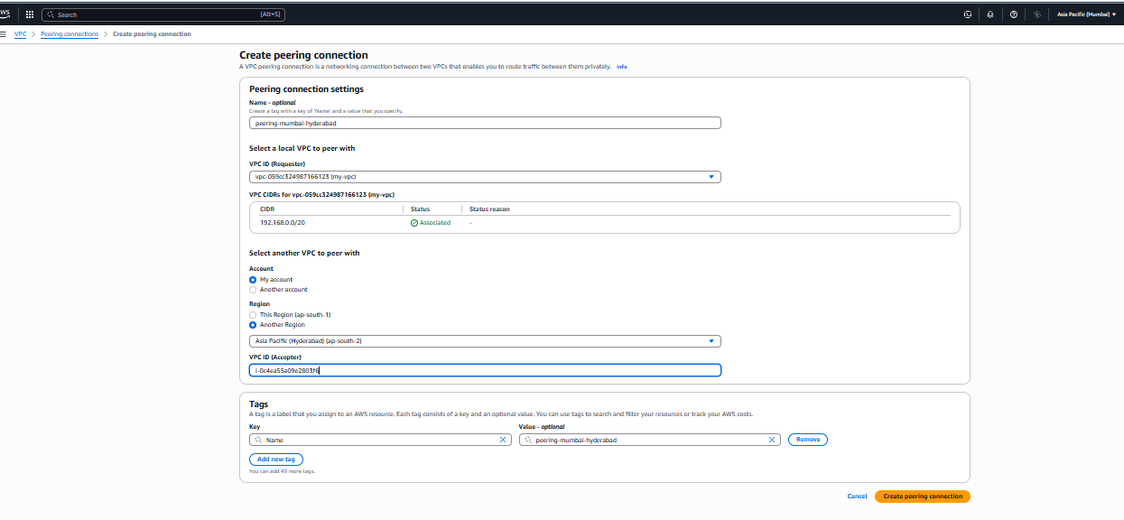

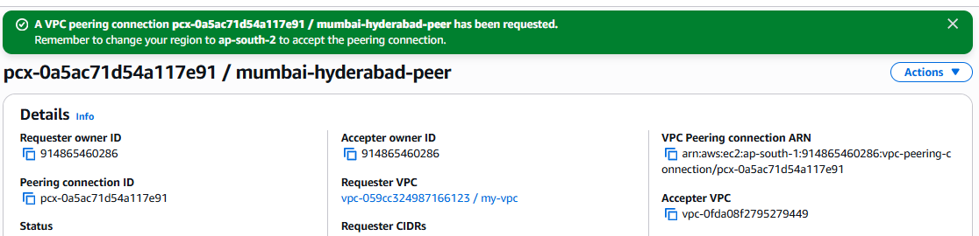

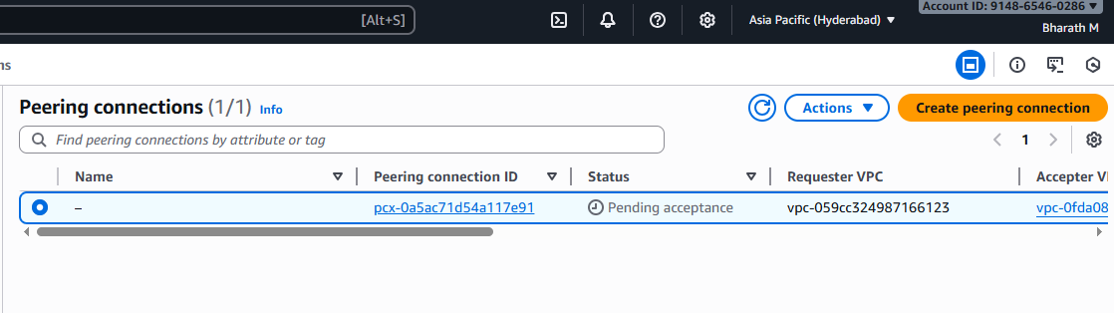
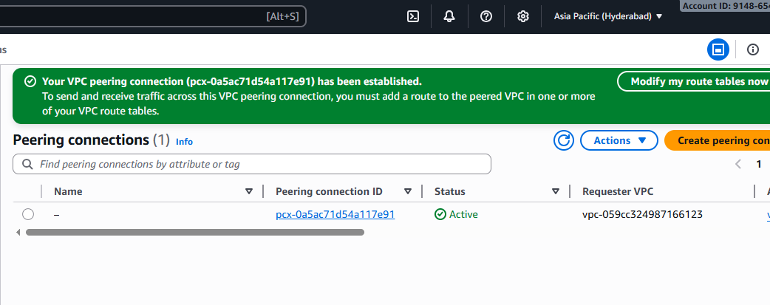
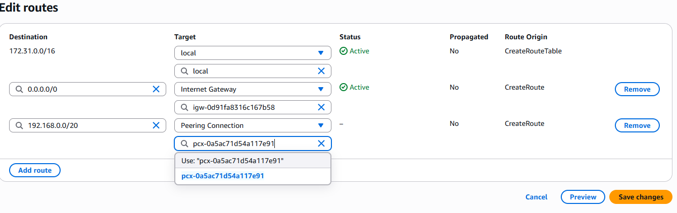
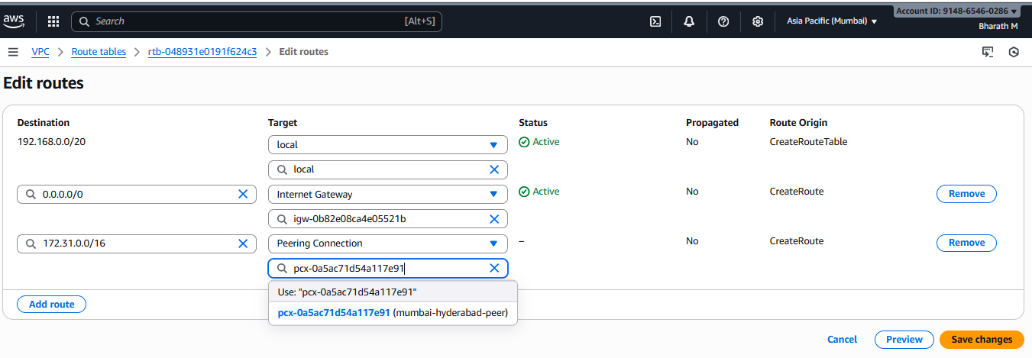

––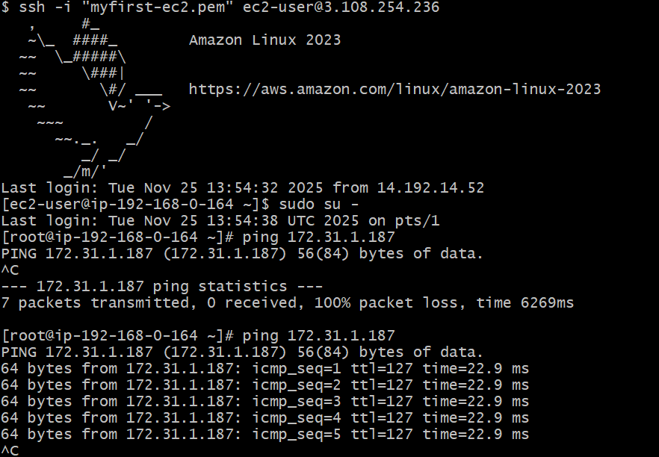

Enable VPC peering for cross-account (you can collaborate with your friend to do this task).

Go to aws console
Go to vpc service
create vpc service and give the CIDR range

Go to vpc peering connections
create peering connections
add name to peering connection
Vpc Id of requester
Account-another account
Account id of the acceptor
Region- another region
vpc region of the acceptor
vpc id of acceptor
create vpc

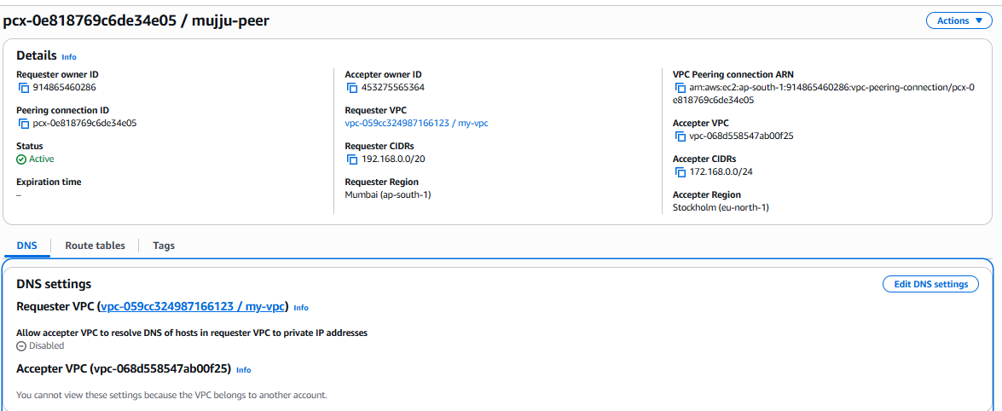

After creating peering connection, request will be sent to Acceptor
After accepting the request from acceptor account
Go to route tables and add CIDR rage of acceptor account VPC and save the changes
same add your CIDR range in acceptor route table and save
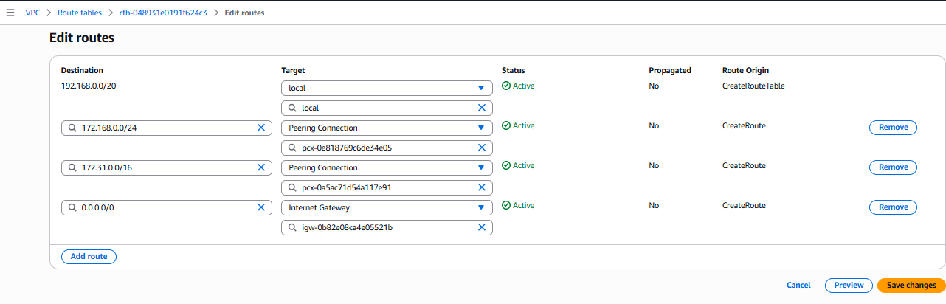
Go to instance security group and edit inbound rules as all traffic and add CIDR of acceptor in source field
same do the configuration in acceptor instance security group
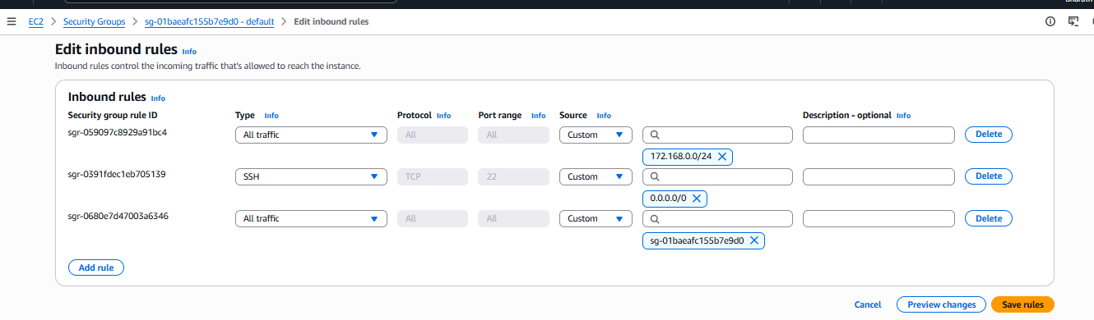
connect to instance and ping with acceptor instance private IP.
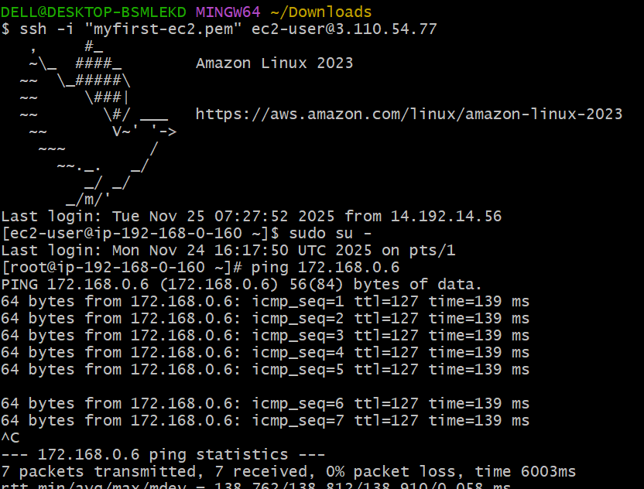
Set up a VPC Endpoint.

Go to aws console
Go to vpc-->create VPC
create internet gateway-->attach to created VPC
create 2 subnets public and private
create 2 route tables public and private
edit route table for public-->add route 0.0.0.0/0 target internet gateway
create 2 ec2 instances public and private one with public subnet and one with private subnet

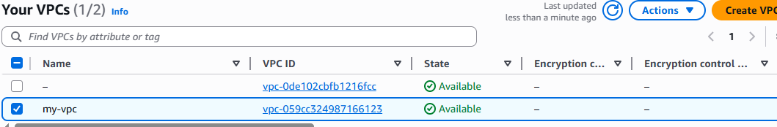
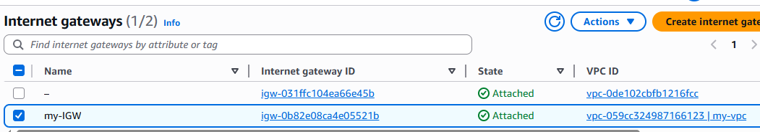
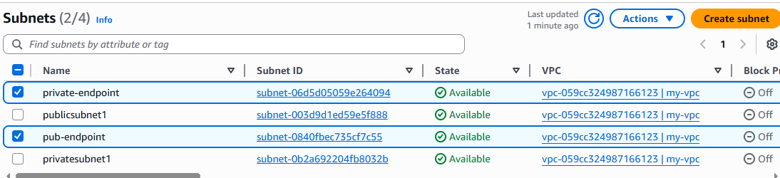
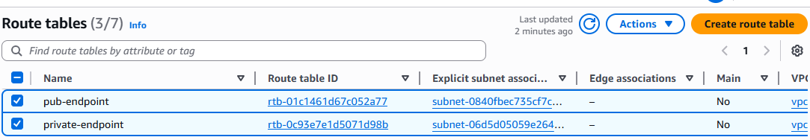
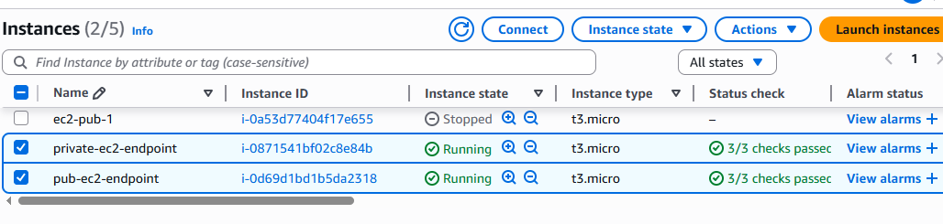
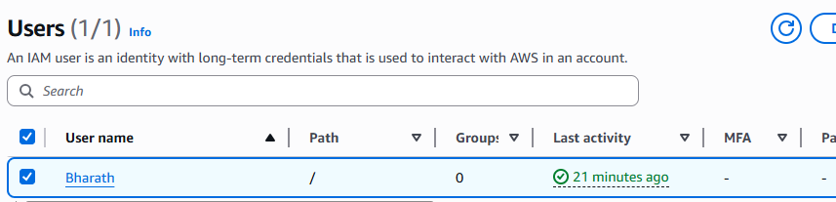

Go to endpoint service create endpoint by selecting gateway , adding s3-service-region, vpc and route table to private.
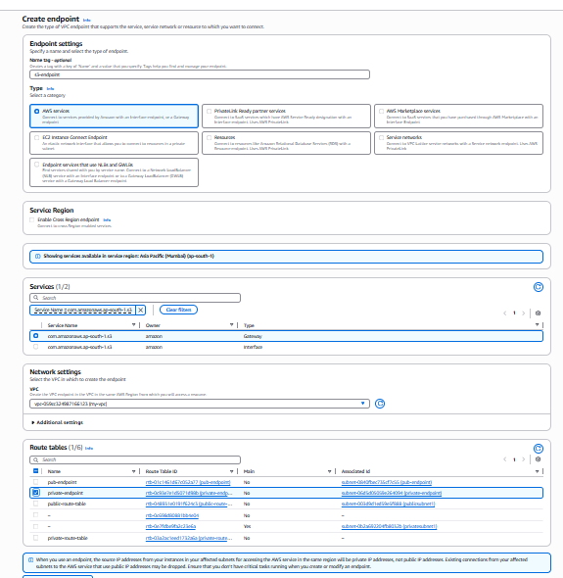
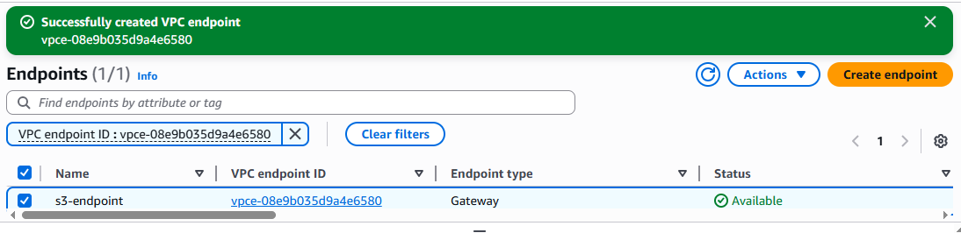
connect to public ec2 instance
Go to root sudo su -
aws configure
crate IAM user and generate key and password
give the access key and password, region and format
use command "aws s3 ls" to see the s3 logs
create a file and paste the pem key of public instance
Now login with private instance ip with in the same server
use command "aws s3 ls"-->command will not execute because we have created any endpoint.
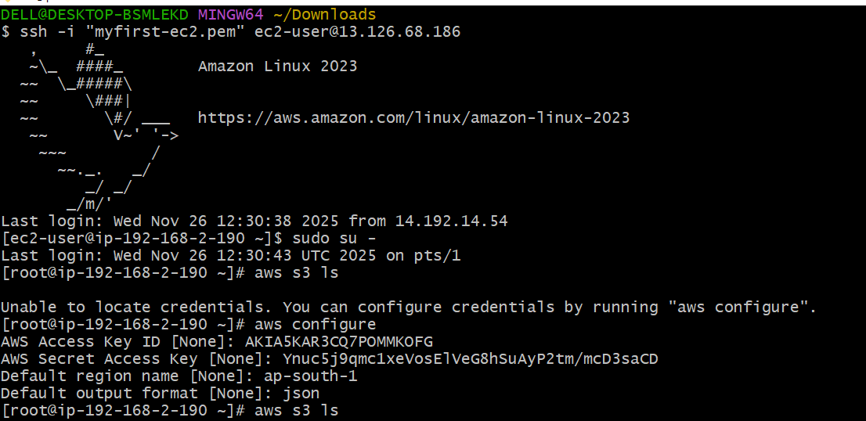
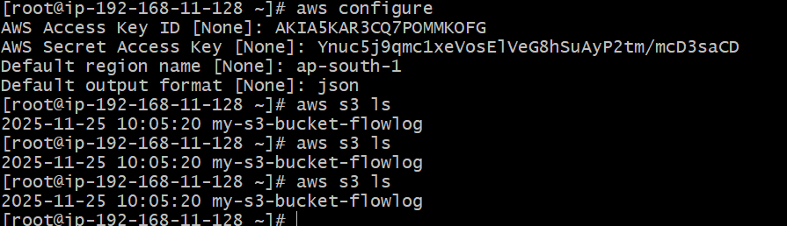
check in CLI with "aws s3 ls" the s3 logs will be available.

Set up a VPC Transit Gateway.

Go to aws console
Go to VPC service
Create multiple VPC
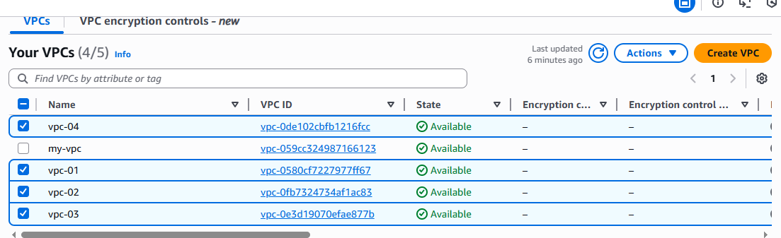

Go to internet gateway and create multiples internet gateway and attach to VPC
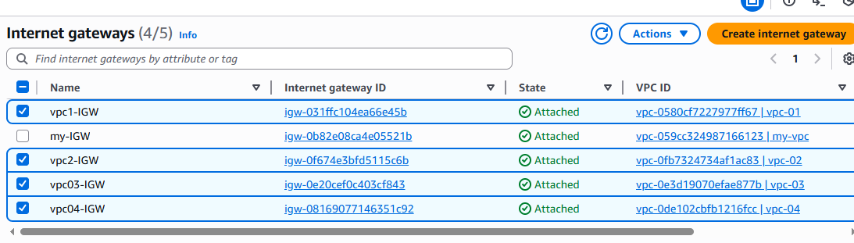

create multiple subnet for multiple VPC
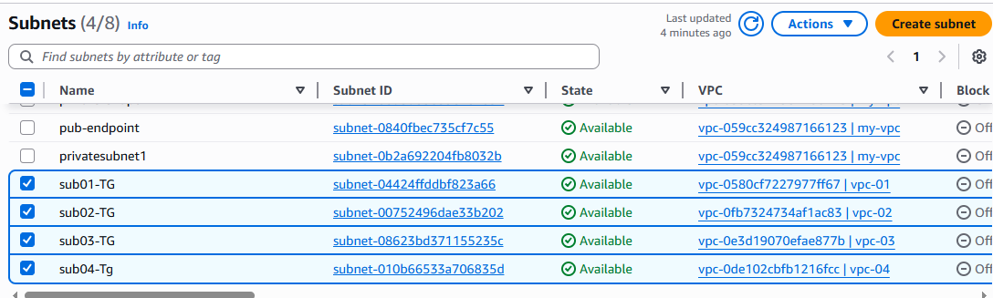

create multiple route tables for multiple subnets and associate with subnets
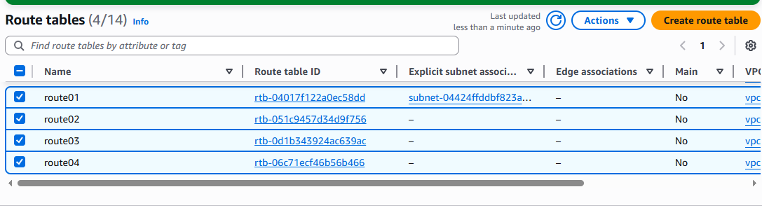
edit route tables and add multiple VPC CIDR to all route tables and add internet gateway.
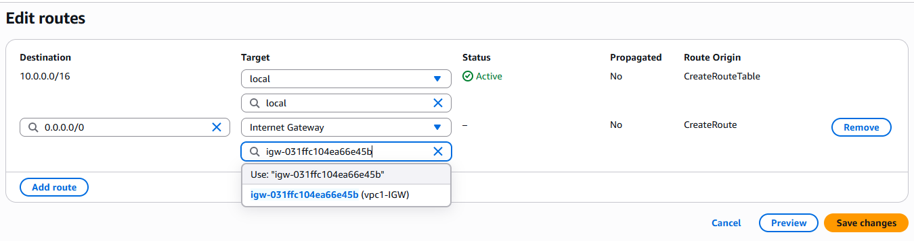

create transit gateway
attach transit gateway to multiple VPC
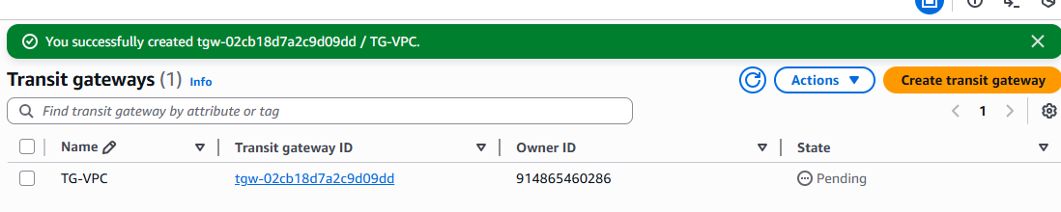
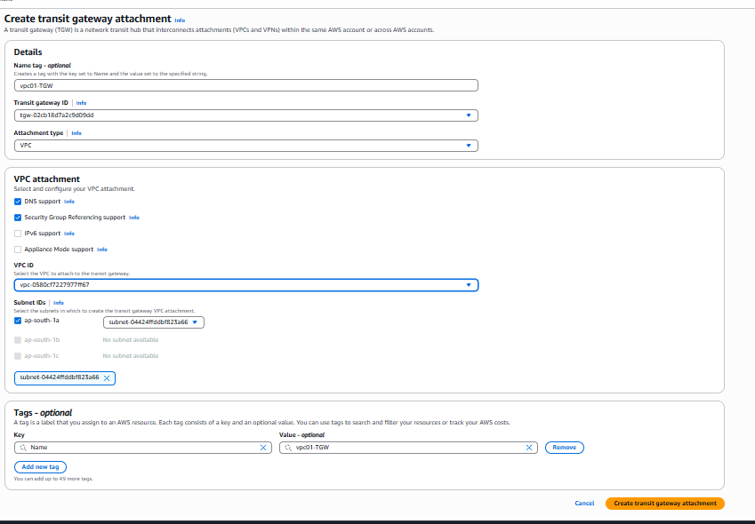
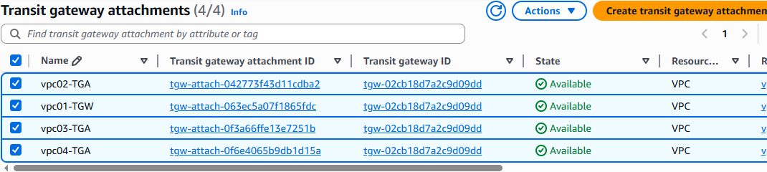
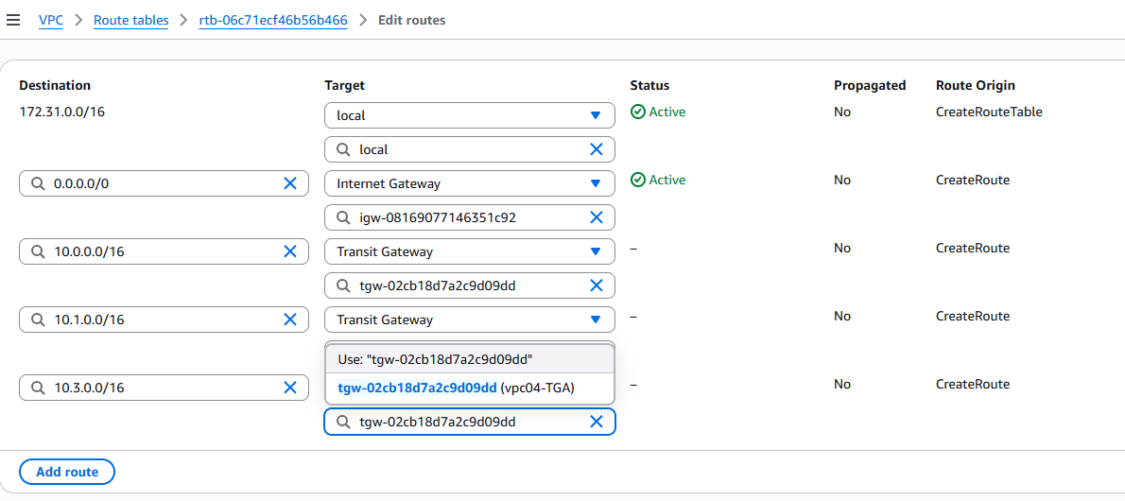

create multiple EC2 instance by adding multiple VPC to instance
change the instance inbound rules to allow all traffic 0.0.0.0/0
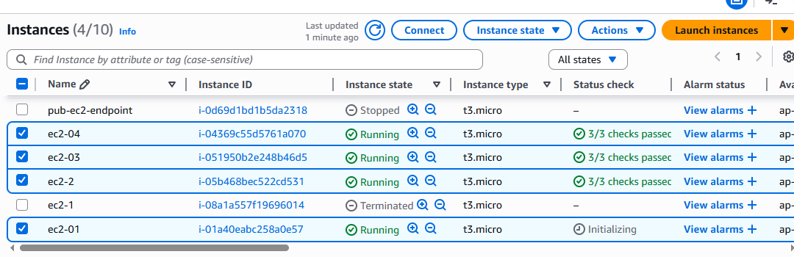
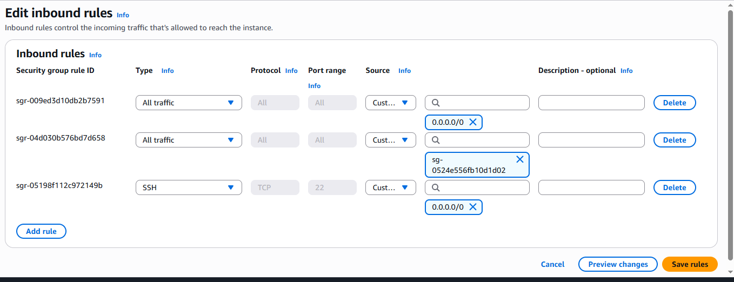

connect to one of the instance and ping with other instance private ip.
